**Name**- Divyam K Deep

**Reg. No**.- RA1911031010096

**Year/Section**- 3rd Yr L1 Section

**Faculty Name**- Dr. P Supraja

# EX 8 : IMPLEMENTATION OF LEARNING ALGORITHMS FOR AN APPLICATION

# Aim:

To implement a supervised learning algorithm.

# Problem Description:

Linear Regression is a machine learning algorithm based on supervised learning. It performs a regression task. Regression models a target prediction value based on independent variables. It is mostly used for finding out the relationship between variables and forecasting.

# Program:

import numpy as np

import matplotlib.pyplot as plt import pandas as pd

import seaborn as sns

%matplotlib inline

companies=pd.read_csv('sample_data/LinearRegressionExample.csv') x=companies.iloc[:,:-1].values

y=companies.iloc[:,4].values companies.head()

print(x) print(y)

sns.heatmap(companies.corr())

from sklearn.preprocessing import LabelEncoder, OneHotEncoder from sklearn.compose import ColumnTransformer

#Encode State Column labelencoder = LabelEncoder()

x[:,3] = labelencoder.fit_transform(x[:,3])

ct = ColumnTransformer([("State", OneHotEncoder(), [3])], remainder = 'passthrough') x = ct.fit_transform(x)

print(x)

x=x[:,1:]

print(x)

from sklearn.model_selection import train_test_split

x_train, x_test, y_train, y_test=train_test_split(x,y,test_size=0.2,random_state=0)

from sklearn.linear_model import LinearRegression model_fit=LinearRegression() model_fit.fit(x_train,y_train)

y_pred=model_fit.predict(x_test) print(y_pred)

print(model_fit.coef_) print(model_fit.intercept_)

from sklearn.metrics import r2_score r2_score(y_test, y_pred)

x_state = companies.State y_profit = companies.Profit

from sklearn.preprocessing import LabelEncoder labelencoder = LabelEncoder()

x_state = labelencoder.fit_transform(x_state) print(x_state)

x_state = np.array(x_state).reshape(-1,1) y_profit = np.array(y_profit).reshape(-1,1)

print(x_state.shape) print(y_profit.shape)

X_train_1, X_test_1, Y_train_1, Y_test_1 = train_test_split(x_state, y_profit, test_size = 0.2, random_state=5)

print(X_train_1.shape) print(X_test_1.shape) print(Y_train_1.shape) print(Y_test_1.shape)

from sklearn.metrics import mean_squared_error reg_1 = LinearRegression()

reg_1.fit(X_train_1, Y_train_1)

y_train_predict_1 = reg_1.predict(X_train_1)

rmse = (np.sqrt(mean_squared_error(Y_train_1, y_train_predict_1))) r2 = round(reg_1.score(X_train_1, Y_train_1),2)

print("The model performance for training set") print('RMSE is {}'.format(rmse))

print('R2 score is {}'.format(r2)) print("\n")

y_pred_1 = reg_1.predict(X_test_1)

rmse = (np.sqrt(mean_squared_error(Y_test_1, y_pred_1))) r2 = round(reg_1.score(X_test_1, Y_test_1),2)

print("The model performance for testing set") print(" ") print("Root Mean Squared Error: {}".format(rmse)) print("R^2: {}".format(r2))

print("\n")

prediction_space = np.linspace(min(x_state), max(y_profit)).reshape(-1,1) plt.scatter(x_state,y_profit)

plt.show()

plt.plot(prediction_space, reg_1.predict(prediction_space), color = 'black', linewidth = 3) plt.ylabel('Profit')

plt.xlabel('State') plt.show()

# Output Screenshot:

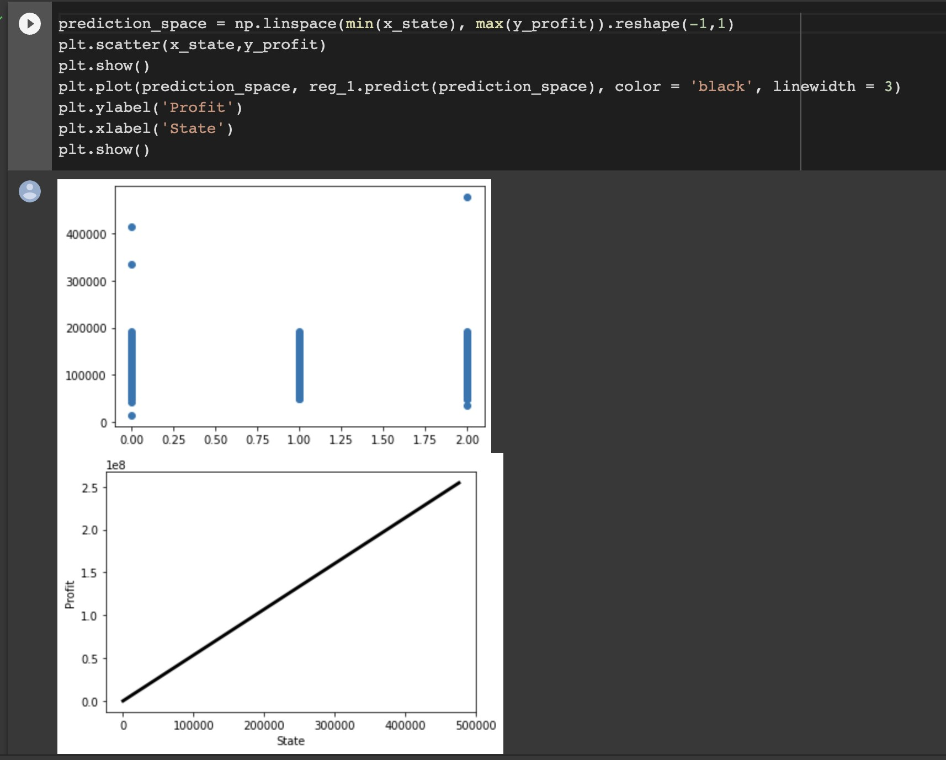

**Result:** The program was executed successfully.

# EX 9 : IMPLEMENTATION OF NLP PROGRAM TEXT CLASSIFICATION

**Aim:**

Solve NLP program for text classification

## Problem Description:

Text clarification is the process of categorizing the text into a group of words. By using NLP, text classification can automatically analyze text and then assign a set of predefined tags or categories based on its context. NLP is used for sentiment analysis, topic detection, and language detection.

# Program:

import pandas as pd import numpy as np

from nltk.tokenize import word_tokenize from nltk import pos_tag

from nltk.corpus import stopwords

from nltk.stem import WordNetLemmatizer from sklearn.preprocessing import LabelEncoder from collections import defaultdict

from nltk.corpus import wordnet as wn

from sklearn.feature_extraction.text import TfidfVectorizer from sklearn import model_selection, naive_bayes, svm from sklearn.metrics import accuracy_score np.random.seed(500)

Corpus = pd.read_csv(r"https://raw.githubusercontent.com/Gunjitbedi/Text- Classification/master/corpus.csv",encoding='latin-1')

# Step - a : Remove blank rows if any.

Corpus['text'].dropna(inplace=True)

# Step - b : Change all the text to lower case. This is required as python interprets 'dog' and 'DOG' differently

Corpus['text'] = [entry.lower() for entry in Corpus['text']]

# Step - c : Tokenization : In this each entry in the corpus will be broken into set of words print(Corpus['text'])

import nltk nltk.download('punkt')

# Step - c : Tokenization : In this each entry in the corpus will be broken into set of words Corpus['text']= [word_tokenize(entry) for entry in Corpus['text']]

print(Corpus['text']) import nltk nltk.download('wordnet')

# Step - d : Remove Stop words, Non-Numeric and perfom Word Stemming/Lemmenting.

# WordNetLemmatizer requires Pos tags to understand if the word is noun or verb or adjective etc. By default it is set to Noun

tag_map = defaultdict(lambda : wn.NOUN) tag_map['J'] = wn.ADJ

tag_map['V'] = wn.VERB tag_map['R'] = wn.ADV import nltk

nltk.download('averaged_perceptron_tagger') import nltk

nltk.download('stopwords')

for index,entry in enumerate(Corpus['text']):

# Declaring Empty List to store the words that follow the rules for this step Final_words = []

# Initializing WordNetLemmatizer() word_Lemmatized = WordNetLemmatizer()

# pos_tag function below will provide the 'tag' i.e if the word is Noun(N) or Verb(V) or something else.

for word, tag in pos_tag(entry):

# Below condition is to check for Stop words and consider only alphabets if word not in stopwords.words('english') and word.isalpha():

word_Final = word_Lemmatized.lemmatize(word,tag_map[tag[0]]) Final_words.append(word_Final)

# The final processed set of words for each iteration will be stored in 'text_final' Corpus.loc[index,'text_final'] = str(Final_words)

print(Corpus['text_final'])

Train_X, Test_X, Train_Y, Test_Y = model_selection.train_test_split(Corpus['text_final'],Corpus['label'],test_size=0.3)

Encoder = LabelEncoder()

Train_Y = Encoder.fit_transform(Train_Y) Test_Y = Encoder.fit_transform(Test_Y) Tfidf_vect = TfidfVectorizer(max_features=5000) Tfidf_vect.fit(Corpus['text_final'])

Train_X_Tfidf = Tfidf_vect.transform(Train_X) Test_X_Tfidf = Tfidf_vect.transform(Test_X) print(Tfidf_vect.vocabulary_) print(Train_X_Tfidf)

SVM = svm.SVC(C=1.0, kernel='linear', degree=3, gamma='auto') SVM.fit(Train_X_Tfidf,Train_Y)

# predict the labels on validation dataset predictions_SVM = SVM.predict(Test_X_Tfidf) # Use accuracy_score function to get the accuracy

print("SVM Accuracy Score -> ",accuracy_score(predictions_SVM, Test_Y)*100)

# Output Screenshot:

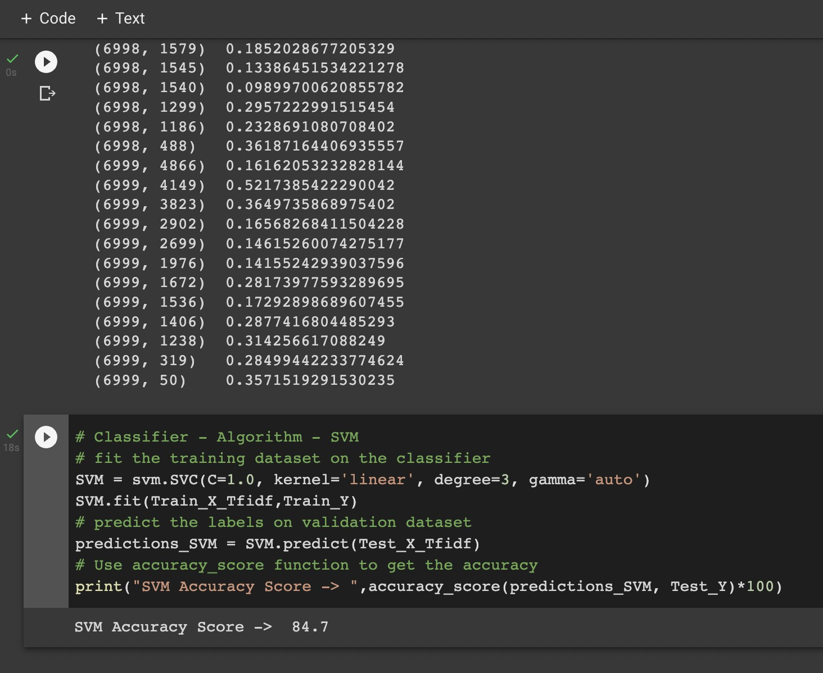

**Result:** The program was executed successfully and accuracy was found.

# EX10 : APPLYING DEEP LEARNING METHODS TO SOLVE AN APPLICATION - CNN ALGORITHM

**Aim:** To write a convolutional neural network algorithm program using deep learning.

**Problem Description: I**n deep learning, a convolutional neural network (CNN/ConvNet) is a class of deep neural networks, most commonly applied to analyze visual imagery.

# Program:

import tensorflow as tf

from tensorflow.keras import datasets, layers, models import matplotlib.pyplot as plt

(train_images, train_labels), (test_images, test_labels) = datasets.cifar10.load_data()

# Normalize pixel values to be between 0 and 1

train_images, test_images = train_images / 255.0, test_images / 255.0

class_names = ['airplane', 'automobile', 'bird', 'cat', 'deer', 'dog', 'frog', 'horse', 'ship', 'truck']

plt.figure(figsize=(10,10)) for i in range(25):

plt.subplot(5,5,i+1) plt.xticks([])

plt.yticks([]) plt.grid(False)

plt.imshow(train_images[i])

# The CIFAR labels happen to be arrays, # which is why you need the extra index plt.xlabel(class_names[train_labels[i][0]])

plt.show()

model = models.Sequential()

model.add(layers.Conv2D(32, (3, 3), activation='relu', input_shape=(32, 32, 3)))

model.add(layers.MaxPooling2D((2, 2)))

model.add(layers.Conv2D(64, (3, 3), activation='relu'))

model.add(layers.MaxPooling2D((2, 2)))

model.add(layers.Conv2D(64, (3, 3), activation='relu'))

model.summary()

model.add(layers.Flatten()) model.add(layers.Dense(64, activation='relu')) model.add(layers.Dense(10))

model.summary()

model.compile(optimizer='adam', loss=tf.keras.losses.SparseCategoricalCrossentropy(from_logits=True), metrics=['accuracy'])

history = model.fit(train_images, train_labels, epochs=10, validation_data=(test_images, test_labels))

plt.plot(history.history['accuracy'], label='accuracy') plt.plot(history.history['val_accuracy'], label = 'val_accuracy') plt.xlabel('Epoch')

plt.ylabel('Accuracy') plt.ylim([0.5, 1]) plt.legend(loc='lower right')

test_loss, test_acc = model.evaluate(test_images, test_labels, verbose=2) print(test_acc)

# Output Screenshot:

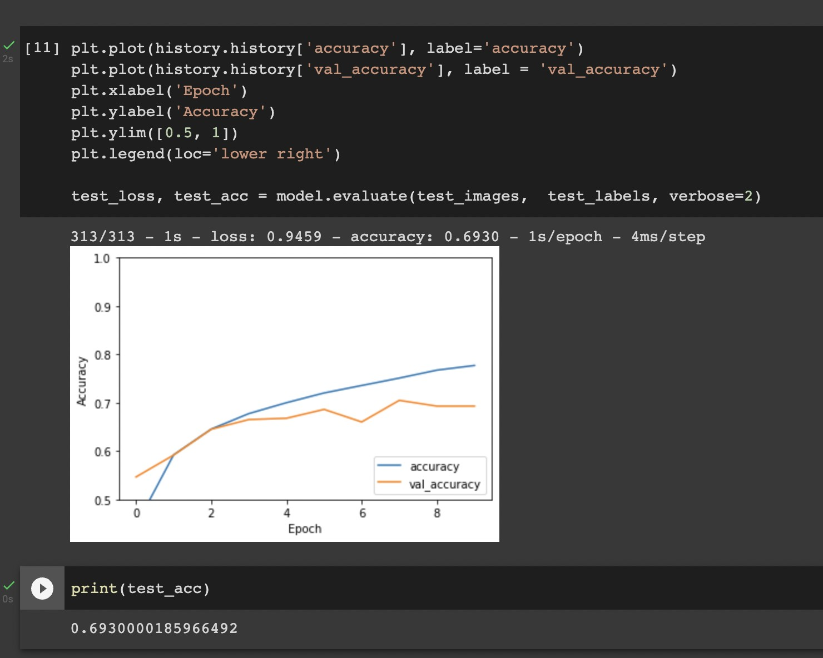

**Result:** The program was executed successfully and accuracy was found.